**Case Study**

**Done By: S.Yazhini**

**Create an ETL pipeline of ingestion & transform and load queries on any data set and initiate the pipeline from workflow using notebook**

**Part1: create a notebook with ETL queries**

**Part2: Run the notebook from workflow pipeline in azure Databricks workspace**

**Notebook created in Azure DataBricks:**

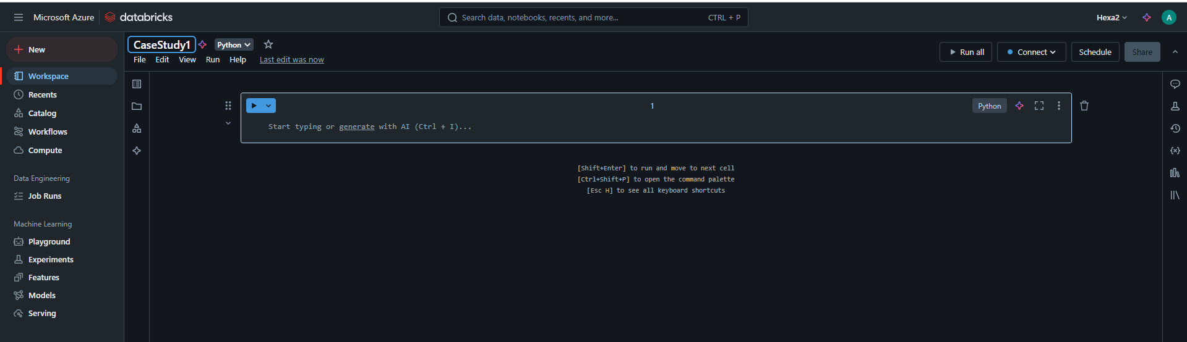

**Data Lake Storage account created (ADLS):**

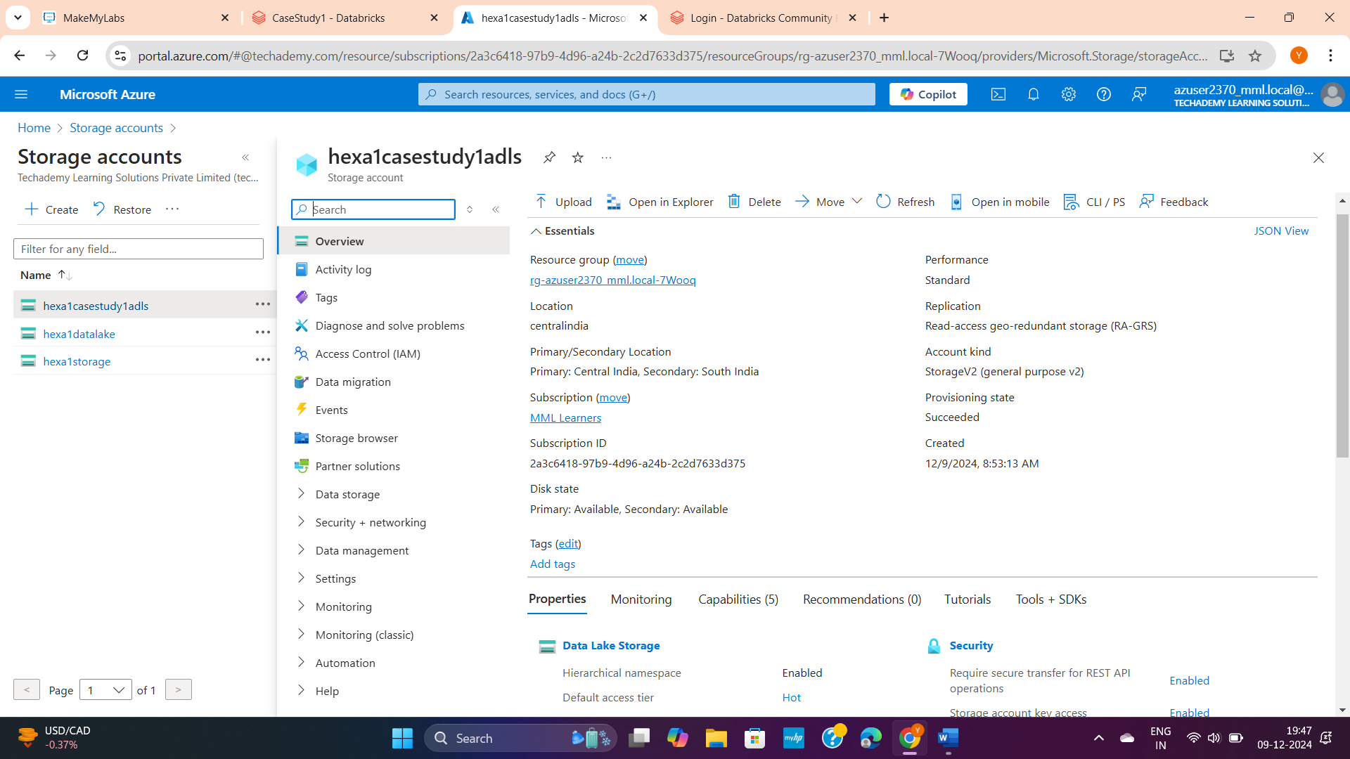

**Containers:**

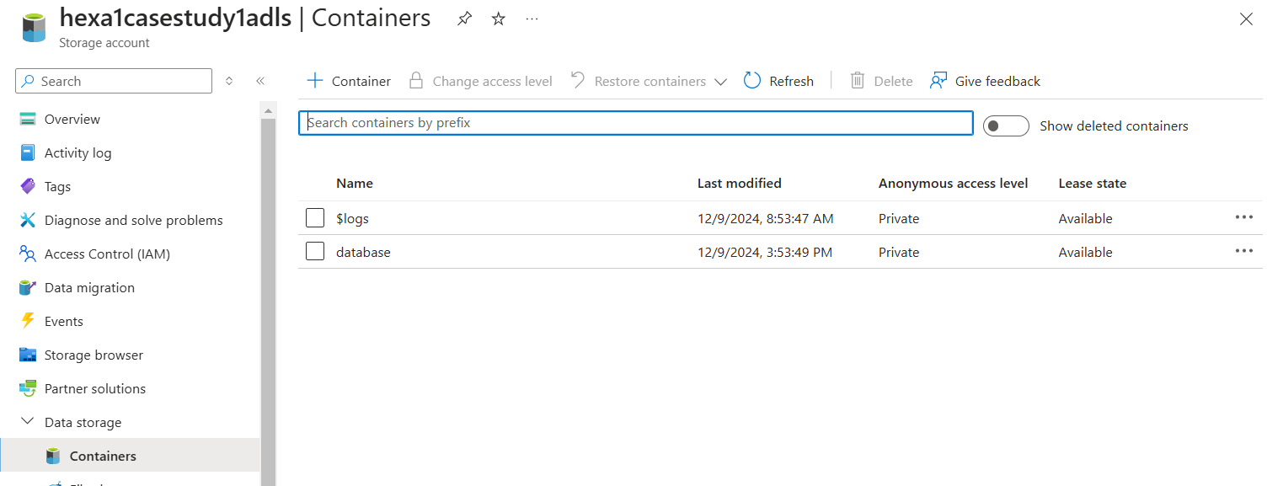

**Database used:**



**ETL operations:**

1. **Extracting database file from ADLS:**

Syntax:

df = spark.read.csv("abfss://<container_name>@<storage_acc_name>.dfs.core.windows.net/<file_name>", header=True, inferSchema=True) – by this we are trying to Load the CSV file from ADLS

df.createOrReplaceTempView("txn_view") – will create a temporary view of our table

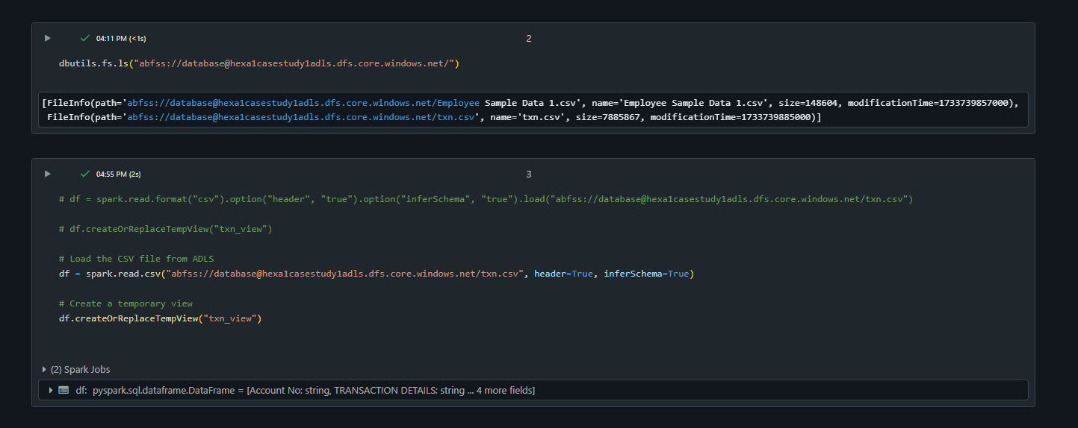

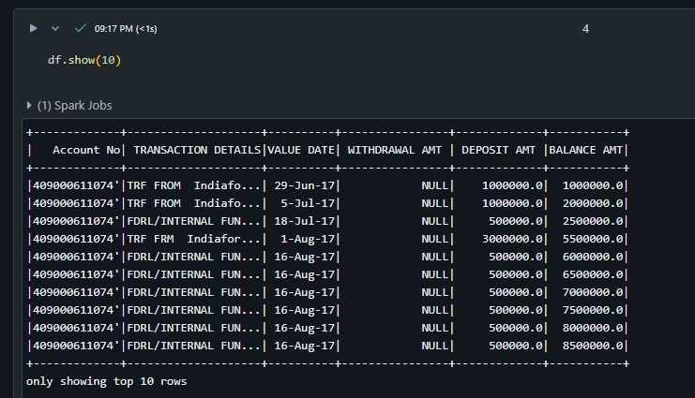

1. **Transforming data:**

**Replacing invalid characters in column names:**

Eg: replacing a column name from “Account No” to “Account_No”

Syntax used:

df_renamed = df.toDF(*[col.replace(" ", "_").replace(".", "").replace(",", "") for col in df.columns])

# Save the DataFrame as a Delta table

df_renamed.write.format("delta").mode("overwrite").saveAsTable("txn_table")

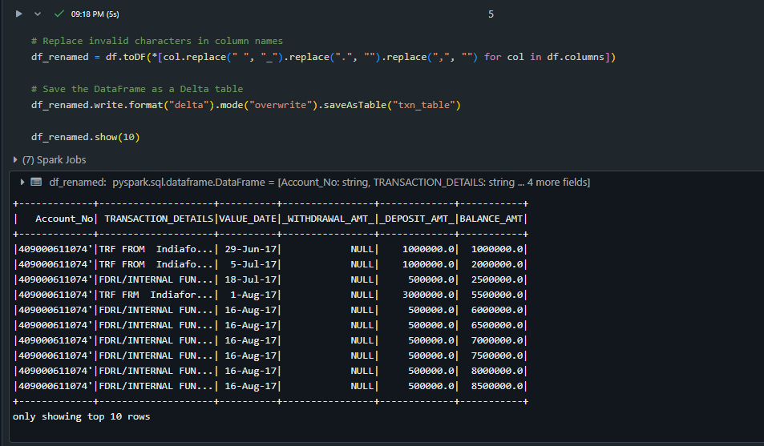

**Converting all the null value to zero:**

Syntax:

# Replace null with 0 only in specific columns

columns_to_update = ["col1", "col3"] # Specify the columns

df = df.na.fill(0, subset=columns_to_update)

df.show()

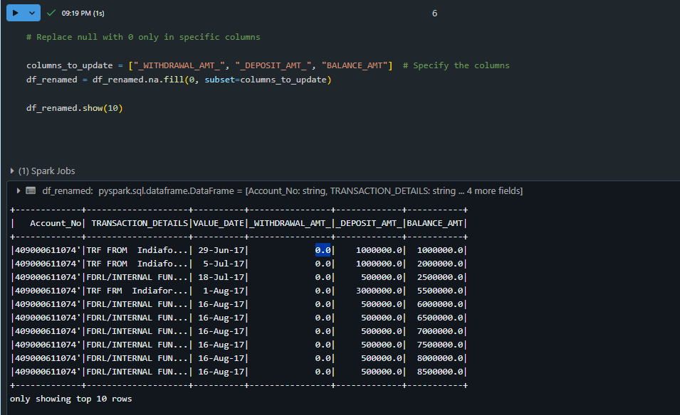

1. **Loading and Visualisation:**

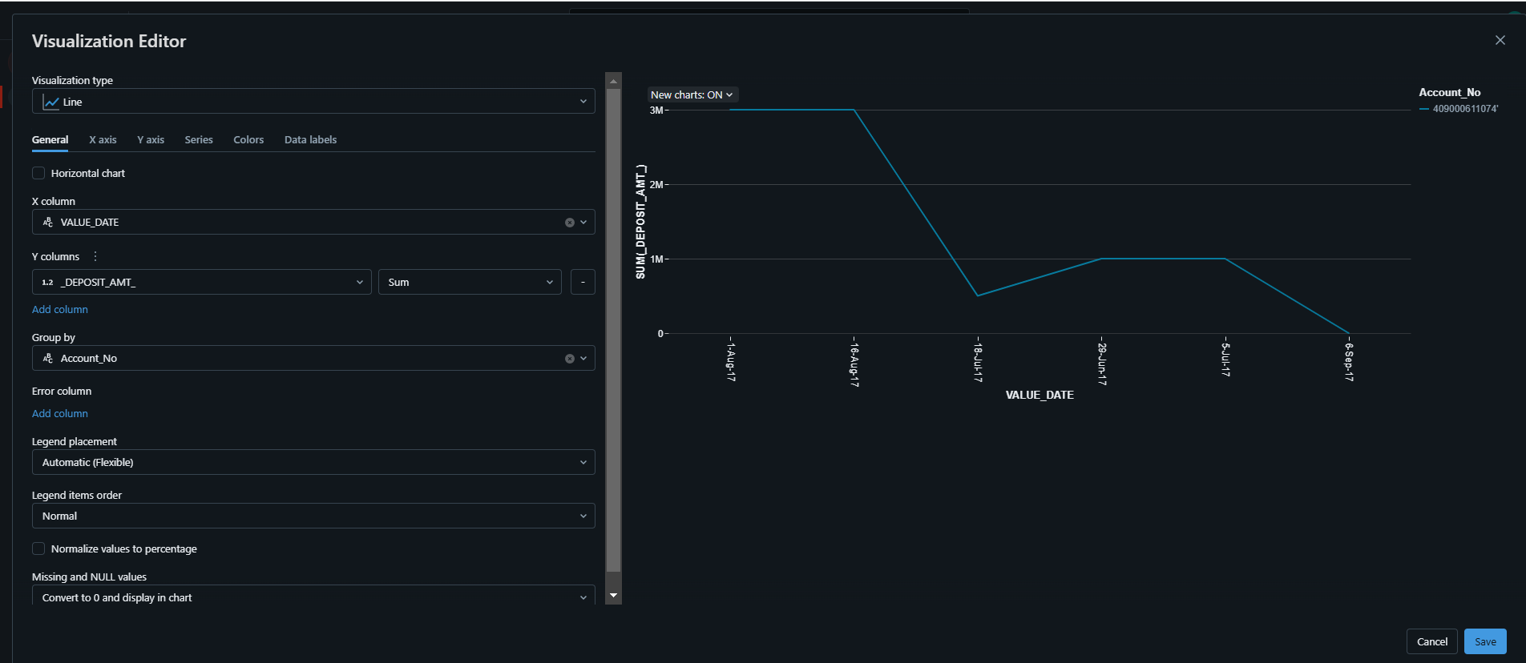

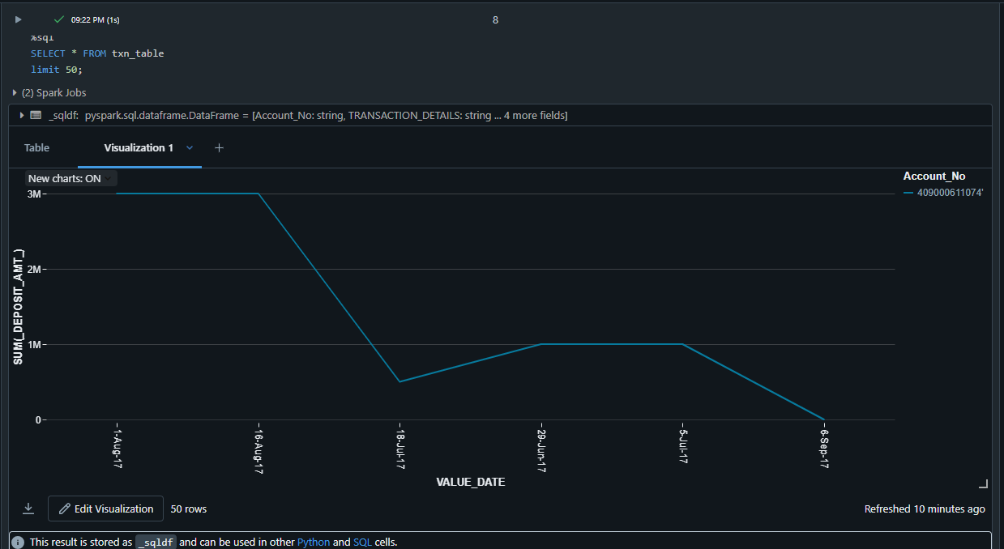

**Part2: Run the notebook from workflow pipeline in azure Databricks workspace**

**Creating job:**

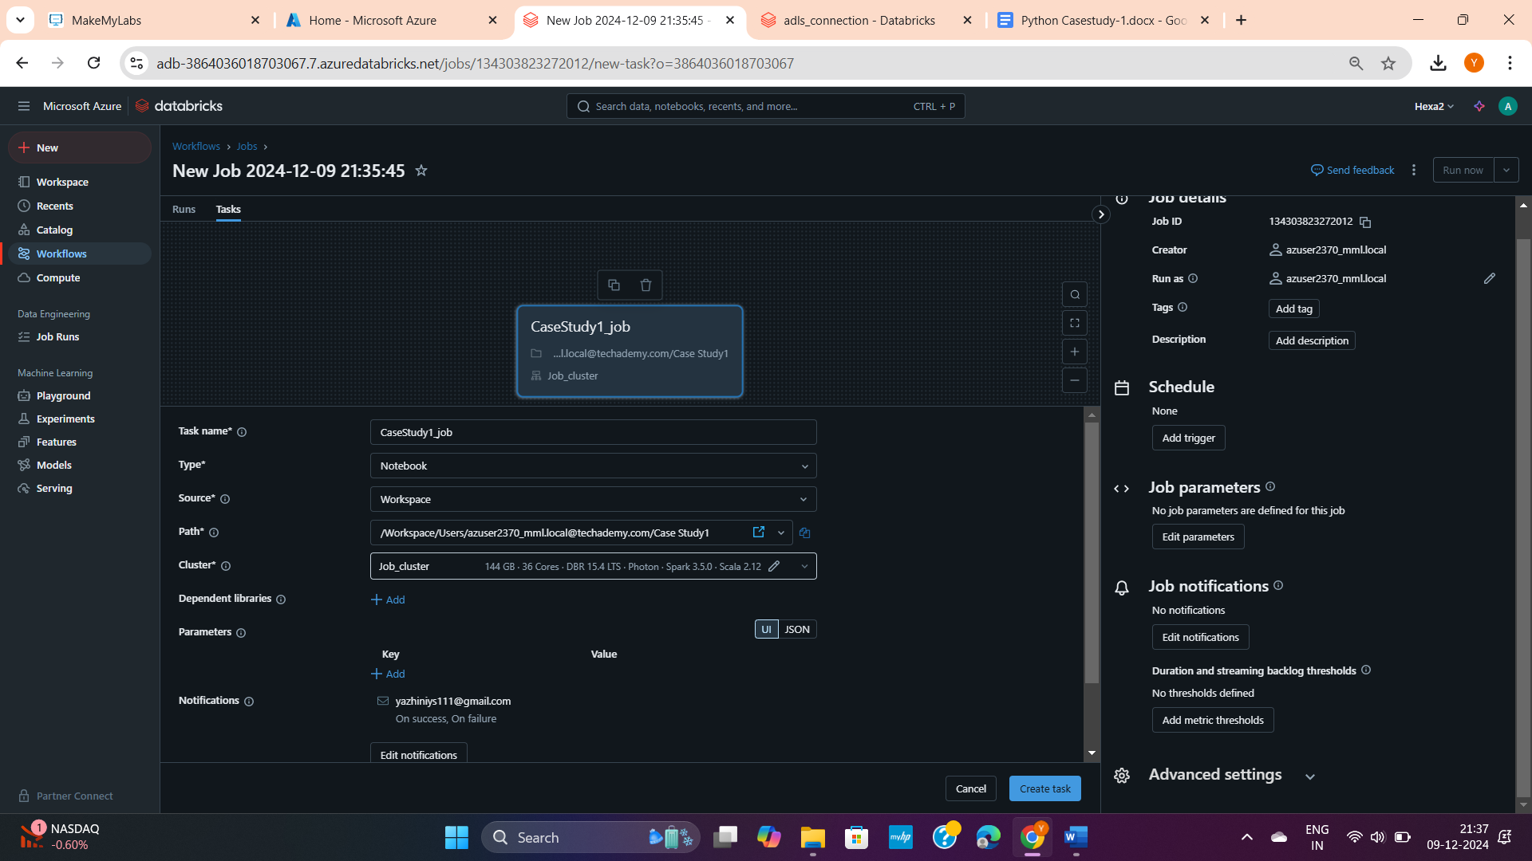

**Job run successful:**

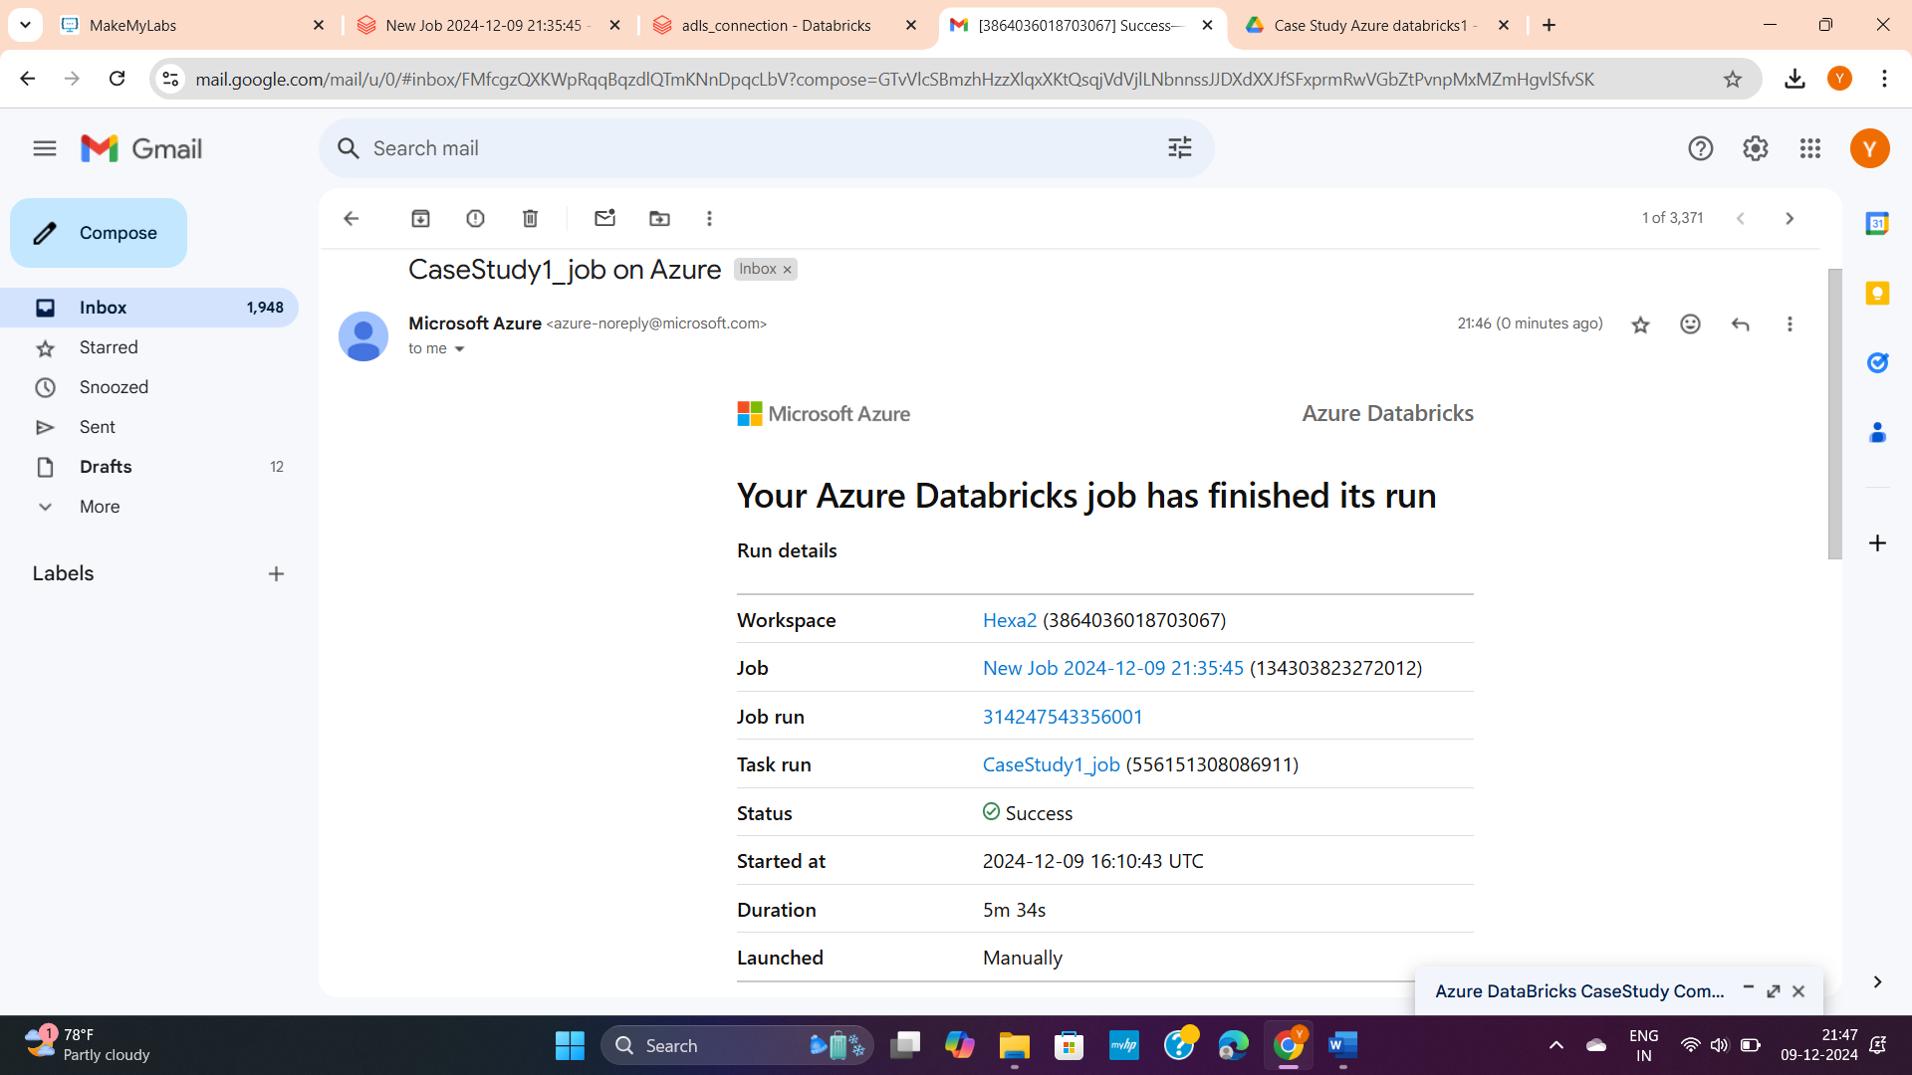

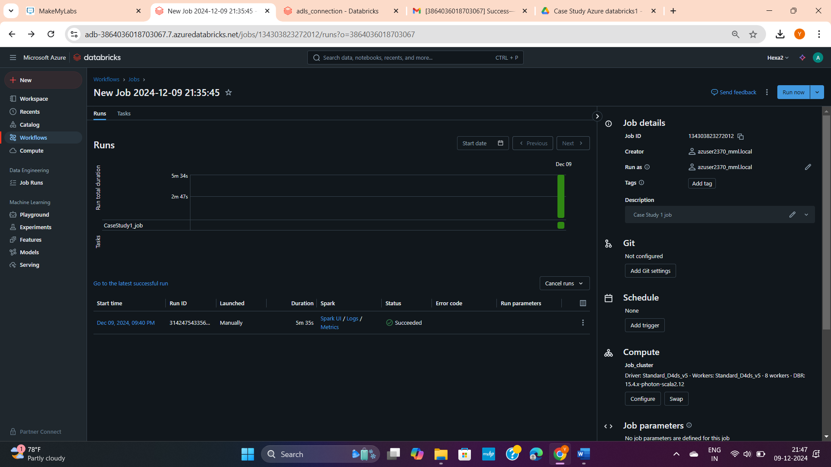

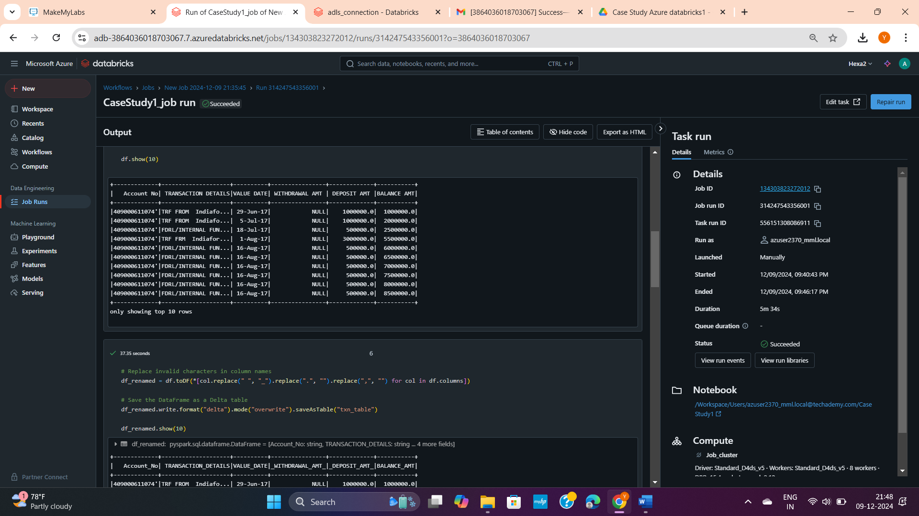

**-------------------------------------Thank you----------------------------------------**